Setting Up GO Mail.

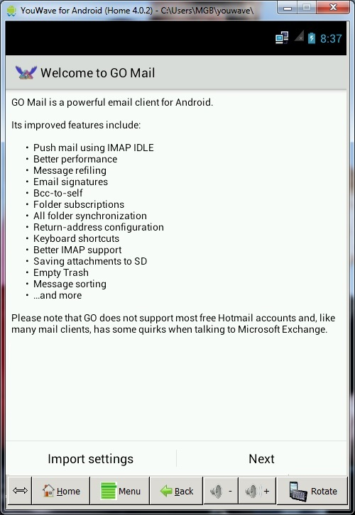

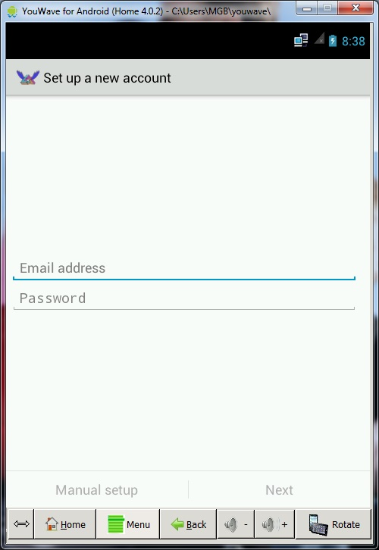

Enter Email Address and Password

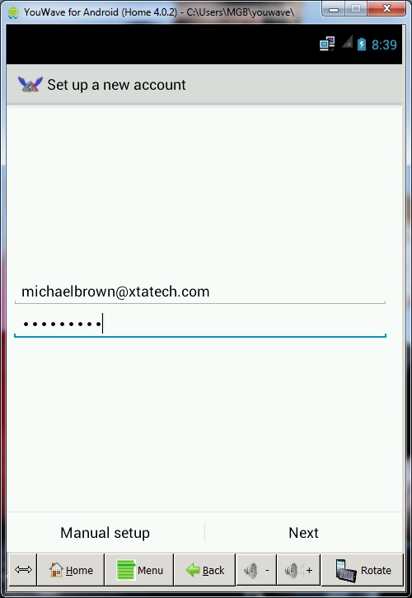

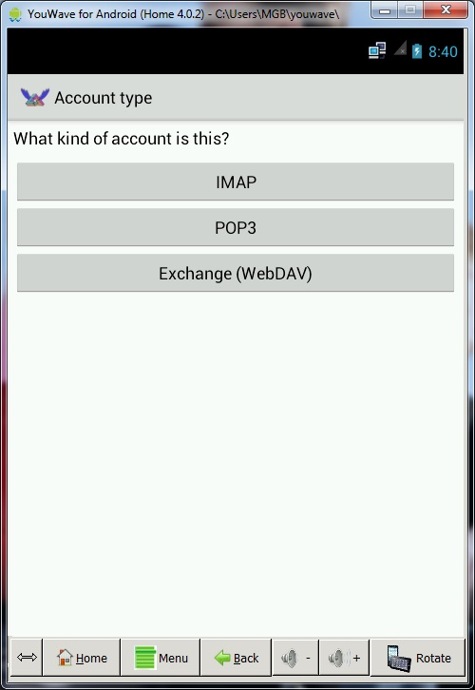

Select appropriate account type. For Internet based accounts most common will be POP3 accounts.

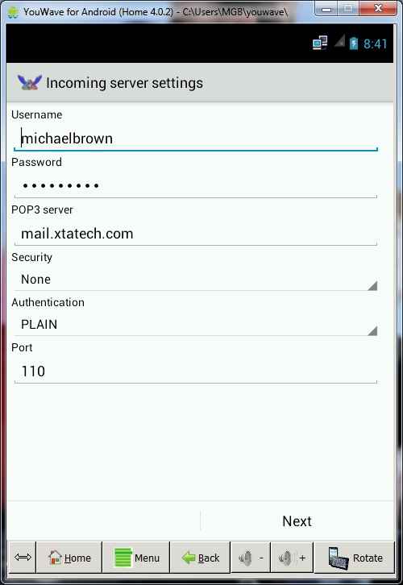

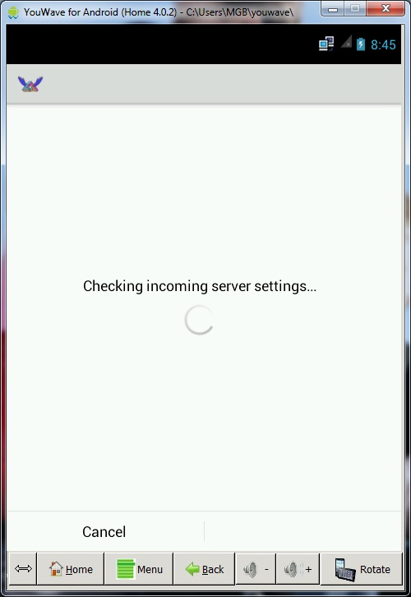

The android will then attempt to complete the connection.

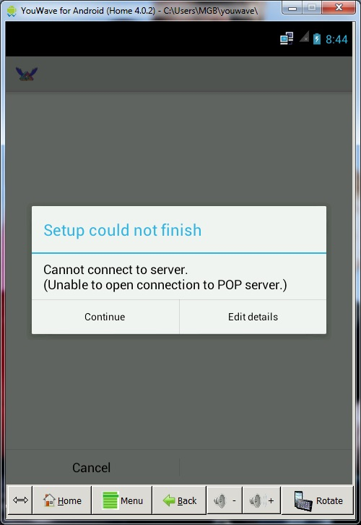

If there Are any connection issues the system will give you guidance as to the correction there of.

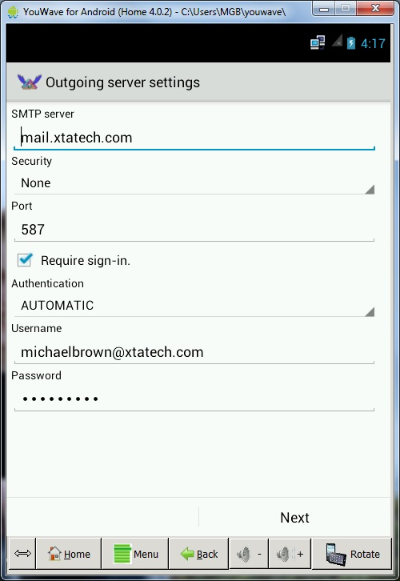

Once the incoming server setup is complete then complete the outgoing.

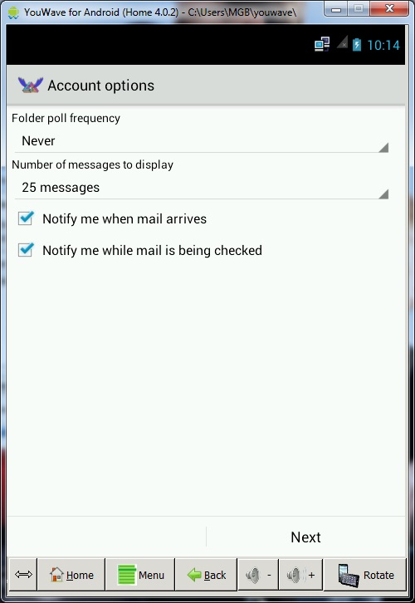

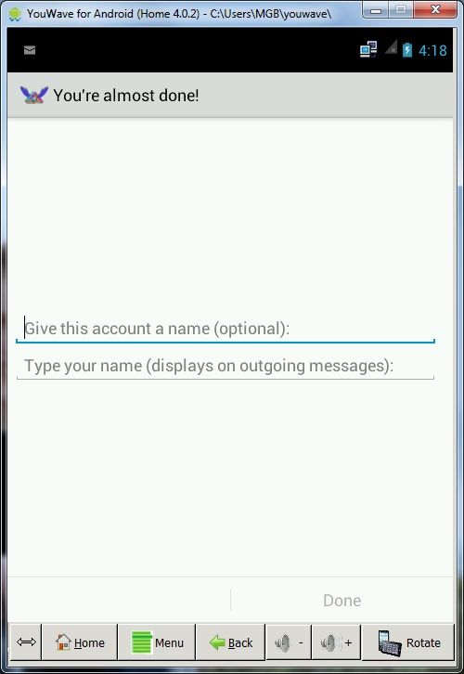

Then just to complete you need to enter the last Information.

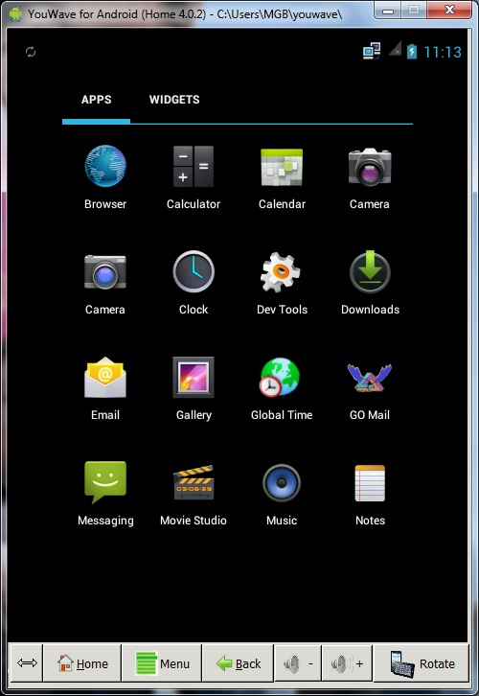

Configuring your Email Account

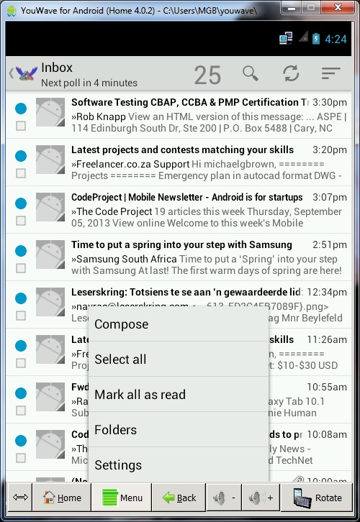

Select Menu on the toolbar at the bottom.

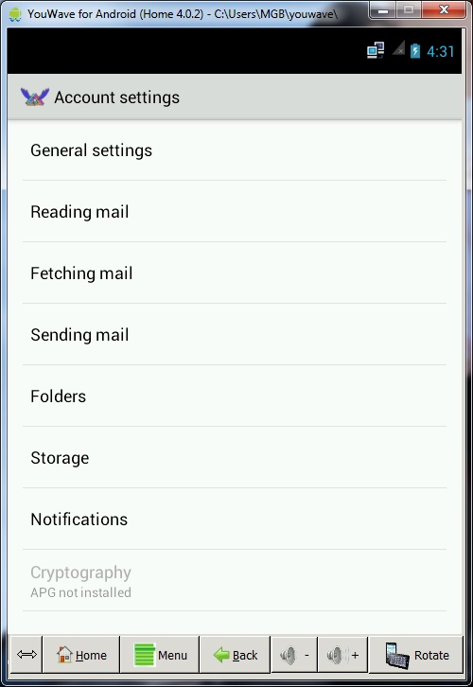

Setting up OTP pass word for sending mail.

Under Sending Mail

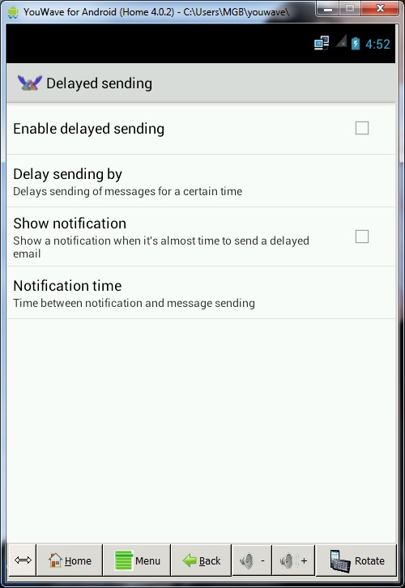

Select delay sending mail



Enable Delayed Sending. This will enable OTP and will allow the option of sending straight away or delaying the mail.

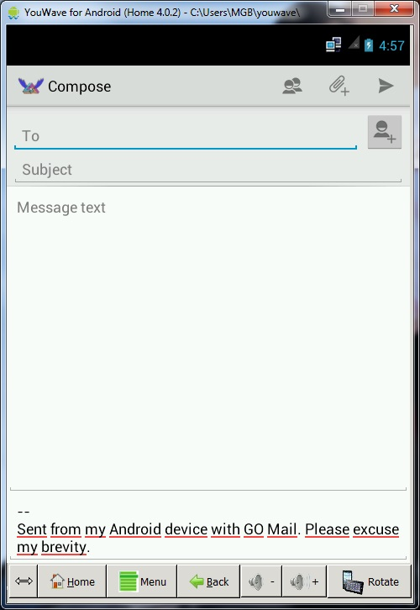

Once mail is composed then send mail.

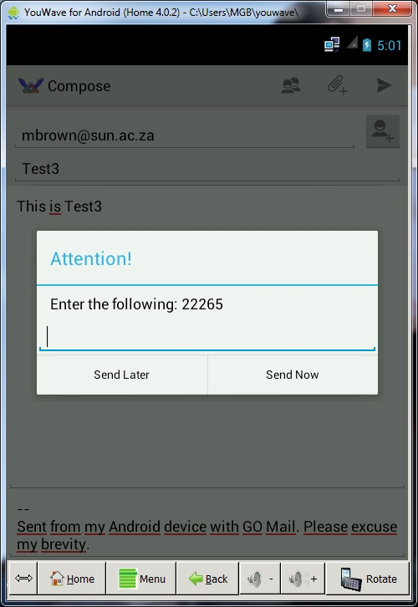

Confirm OTP and then send mail

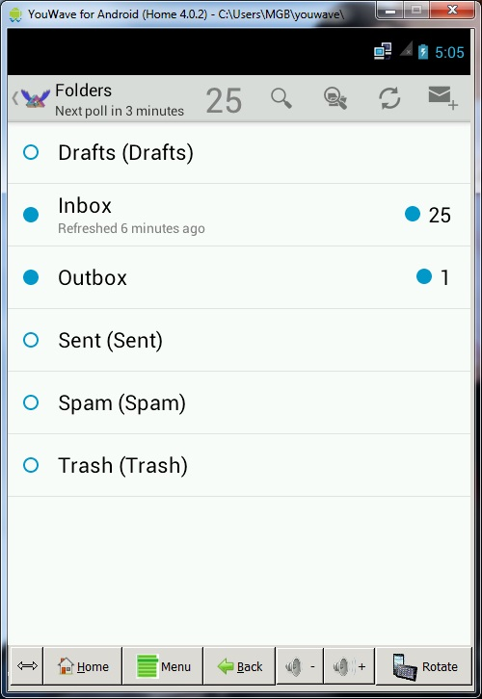

It will then go into outbox and dependant on connectivity and whether a delay was set, will move into the sent folder.

Setting Up Delay



Enable Delay and select Delay Sending By.

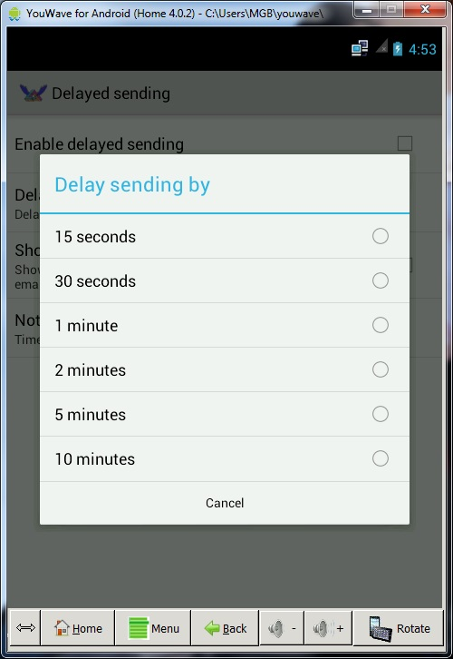

Select the Time that you would like to delay by.

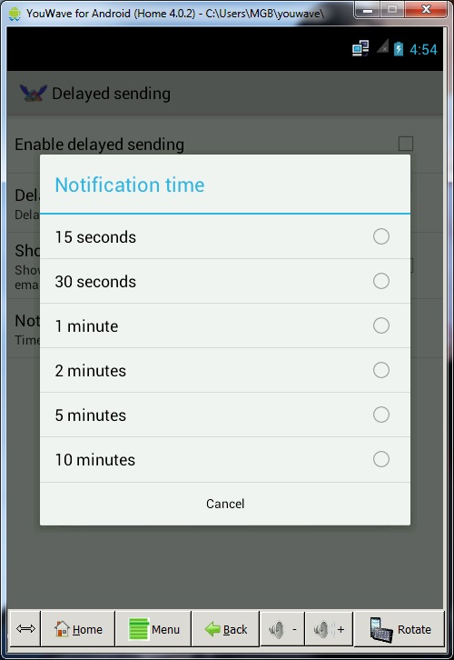

You can set the notification of the delay as well.

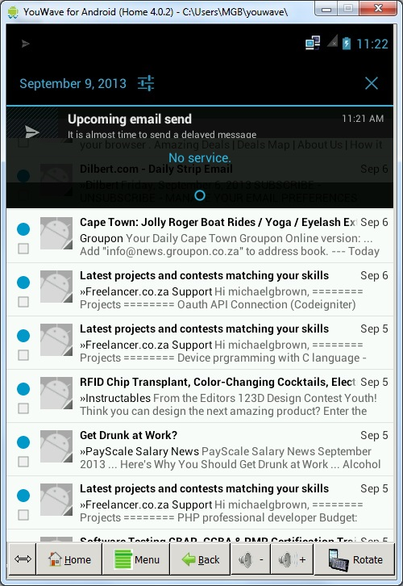

When the predetermined delay time is complete then the notification of pending mail send will be displayed.

Setting Up Confirmed Receipt.

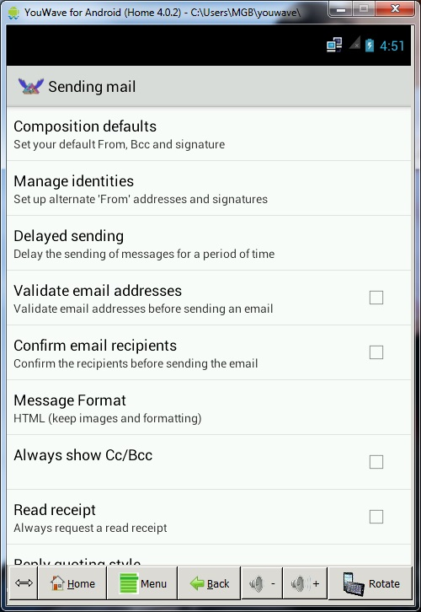

Select Confirm Email Receipts.

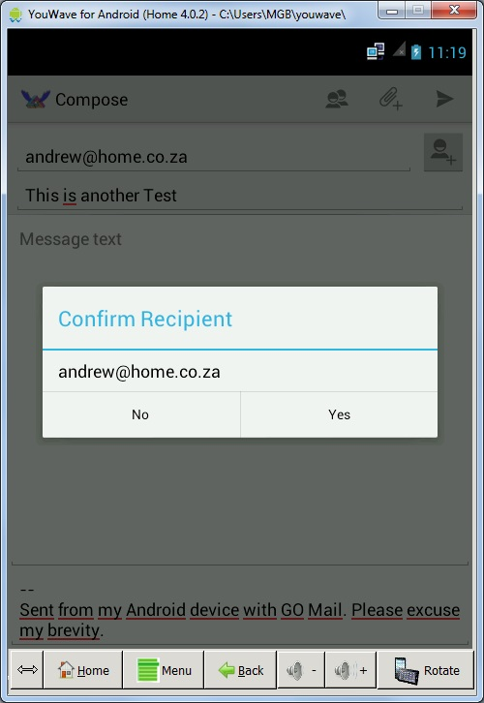

With confirmation selected once you have composed your mail and send it the system will confirm each of the addresses that you have added in your mail

Validate Address.



Select Validate Email Address.

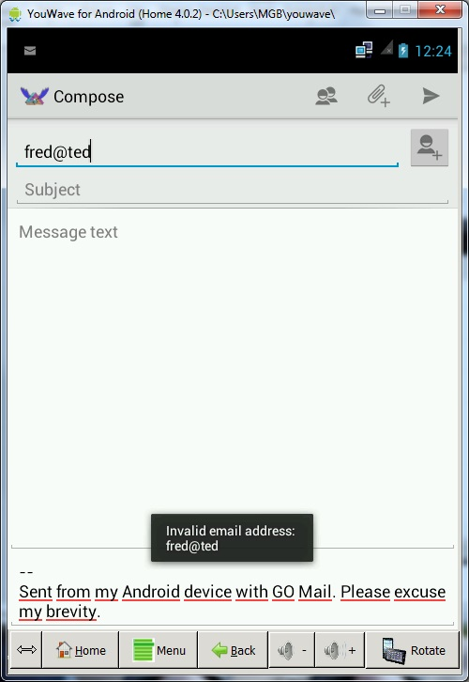

Email Address is Invalid.